Project Status Report 3
Noise and echo cancellation in a teleconference
Date: 29th April 2015

Project Status Summary
Our goal in this project is to appropriately apply noise cancellation in such a way which enables the system to extract only the voice signal removing as much noise as possible for a great teleconference experience.

To complete the project successfully, our project group and tasks are divided into 3 parts: Android group, Theory group and Management group.

The project schedule is perfectly in line with the schedule and we are confident to complete the project within due date. If required, the members are also planning to accelerate the progress by working weekends and extended hours in the next few weeks.

Work Planned till 29th April, 2015
Android Part: As stated in the previous report, we have already completed all the android tasks before our own set deadline, and thus we didn’t plan to work much on this part, rather refining our works.

Theory Part: The main goal was be to make research on below points:
- Non-linear algorithms: make a non-linear model and test them in MATLAB
- Wiener Filtering with the new model
- Test LMS in different scenarios being the main goal the avoidance of residual voice in the noise recordings
- Record the noise from another room
- Record from a louder noise source using an amplifier.

Management Part: Following up the progress of the group was set as the core responsibility of the management group.

Work Completed till 29th April, 2015
Android Part: As all the tasks were successfully completed on last week, we only worked to refine our outcome on this part.

Theory Part: There have been different areas where to work:
- RLS: no much success with it.
- LMS frequency domain: has turned out to be substantially faster than the time domain (sample) LMS although the result is not as natural.
- Non-Linear Algorithms: there has only been one algorithm found on the literature on the internet which are the Volterra Series. No results yet.
- Wiener Filtering: latest approach considered (based on statistics and a voice-unvoice detector). In modelling process and without results in testing yet.

Management Part: Every members work progress was monitored and followed-up as required to finish everything within the set timeline and integrated to the progress report.

Work Planned For Next Week
The main goal will be to make research on next points:
- Non-linear algorithms: make a non-linear model and test them in MATLAB
- Wiener Filtering with the new model
- Test LMS in different scenarios being the main goal the avoidance of residual voice in the noise recordings
  - Record the noise from another room
  - Record from a louder noise source using an amplifier.

Open Issues
Once we have had results in real time application from the Android section, the main goal will be to research in new techniques not necessarily real-time oriented.

Risk Analysis
The update of the risk analysis remains as the one in the project plan (see the table below).

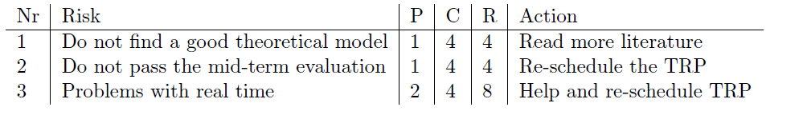
As per the above table, the risk number 1 & 2 are less likely to affect our project outcome because we have good theoretical model with good performance and we have already completed all the 7 android tasks assigned for the mid-term evaluation.

Currently our main concern is the third risk factor, which might take a lot of time, but we are working hard to eliminate this risk factor as much as we can.

Key Performance Indicators (KPI's)
To have a better understanding of the progress of the project the Gantt chart and the working hours of every individual compared to resource allocation table is attached as annexures below:

